# Changes in this version DocX version 1.0.0.9

## Hyperlinks

The Document class now contains AddHyperlink(string, Uri)  
The Paragraph class now contains AppendHyperlink(Hyperlink);

Example

// Create a document.

using (DocX document = DocX.Create(@"Test.docx"))

{

// Add a hyperlink to this document.

Hyperlink h = document.AddHyperlink

("Google", new Uri("http://www.google.com"));

// Add a new Paragraph to this document.

Paragraph p = document.InsertParagraph();

p.Append("My favourite search engine is ");

p.AppendHyperlink(h);

p.Append(", I think it's great.");

// Save all changes made to this document.

document.Save();

}

Output

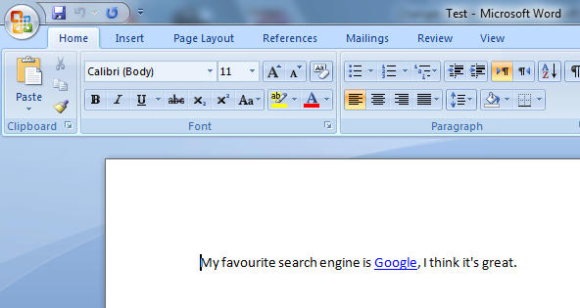

## Content Direction

The Paragraph class now contains a property called Direction which can be either LeftToRight or RightToLeft. This property has both a getter and setter function.

To accommodate Paragraph Direction

* The Document class now contains SetDirection(Direction)
* The Table class now contains SetDirection(Direction)
* The Row class now contains SetDirection(Direction)
* The Cell class now contains SetDirection(Direction)

Where Direction is an enum with the choices LeftToRight and RightToLeft.

Example

// Create a new document.

using (DocX document = DocX.Create("Test.docx"))

{

// Create a new Paragraph with the text "Hello World".

Paragraph p = document.InsertParagraph("Hello World.");

// Make this Paragraph flow right to left. Default is left to right.

p.Direction = Direction.RightToLeft;

// Save all changes made to this document.

document.Save();

}

Output

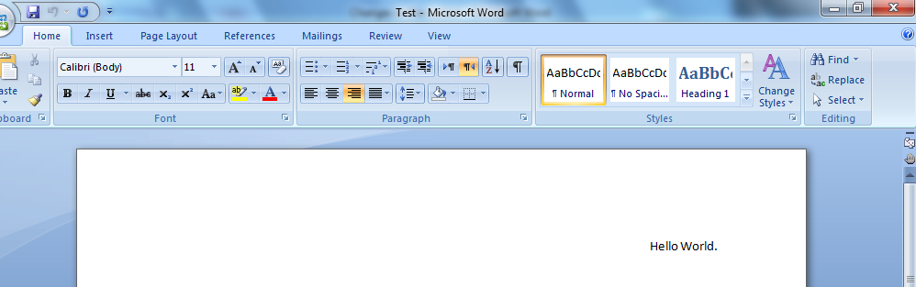

## Indentation

The Paragraph class now contains four properties for setting Indentation.   
  
IndentationFirstLine(float) which indents only the first line of a paragraph.  
IndentationHanging(float) which indents all but the first line of a paragraph.  
IndentationBefore(float) which indents before content.  
IndentationAfter(float) which indents after content.

Example

// Create a new document.

using (DocX document = DocX.Create("Test.docx"))

{

// Create a new Paragraph.

Paragraph p = document.InsertParagraph("Line 1\nLine 2\nLine 3");

// Indent only the first line of the Paragraph.

p.IndentationFirstLine = 1.0f;

// Save all changes made to this document.

document.Save();  
}

Output

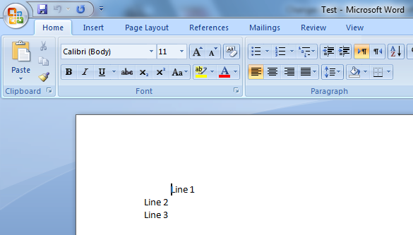

## Pictures

The Image class now contains a CreatePicture() function and the Paragraph class contains a AppendPicture(Picture) function. The below example should explain how these updates enable easier Paragraph building.

Example

using (DocX document = DocX.Create("Test.docx"))

{

// Add an image to the document.

Image i = document.AddImage(@"Image.jpg");

// Create a picture i.e. (A custom view of an image)

Picture p = i.CreatePicture();

p.FlipHorizontal = true;

p.Rotation = 10;

// Create a new Paragraph.

Paragraph par = document.InsertParagraph();

// Append content to the Paragraph.

par.Append("Here is a cool picture")

.AppendPicture(p)

.Append(" don't you think so?");

// Save all changes made to this document.

document.Save();

}

Output

